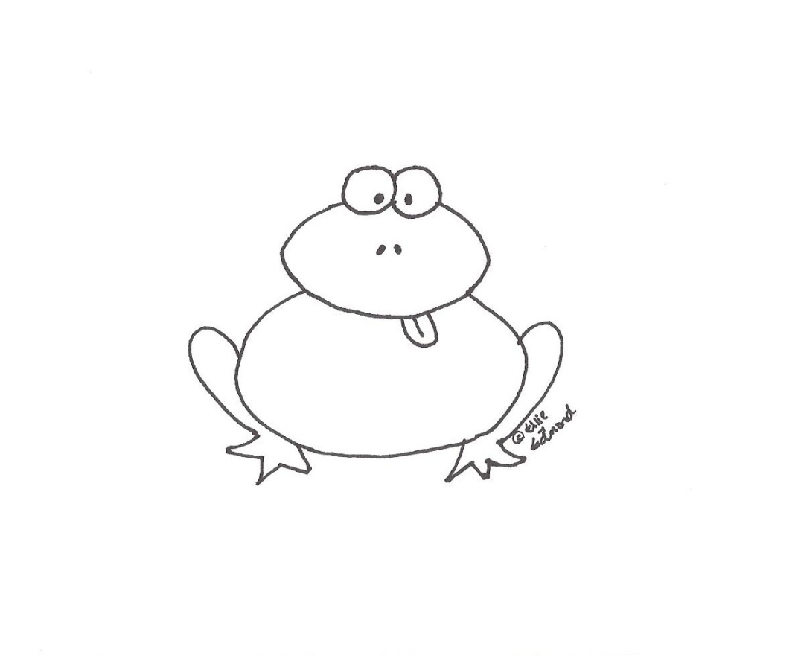
I’ll be so Hoppy if
You’d be my Valentine!

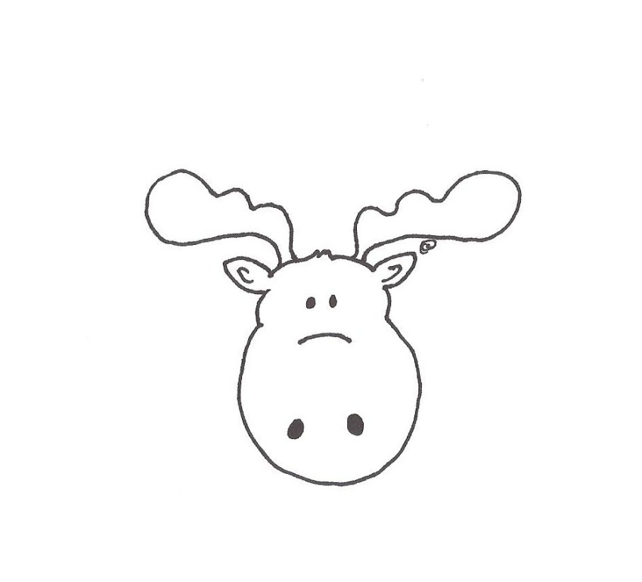
You Moose Be My Valentine!

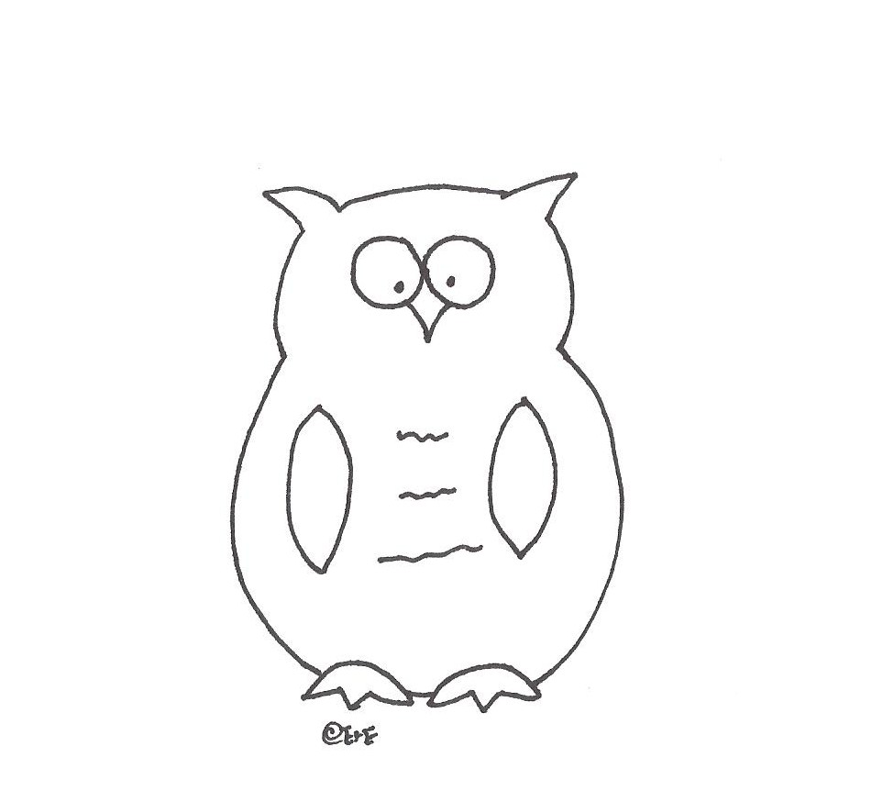
Whoooooo will be my Valentine?
Will yoooouuu be my Valentine?

